Title: Eu External Policy
Subject: EE6

1. Eu Trade Policy  A. Internal Dimension  B. External Dimension  2. External dimension  A. How to create a new trade Agreement  B. Eu believes in free trade. That’s why Eu:  A. Is in WTO  a. What’s WTO  b. Objectives  c. Priciples  d. What it does  I. Negotiating forum  II. Resolution of trade disputes  B. Negotiates FTA  a. Pyramid of preferences  4. Note: Bilateral agreements vs WTO | 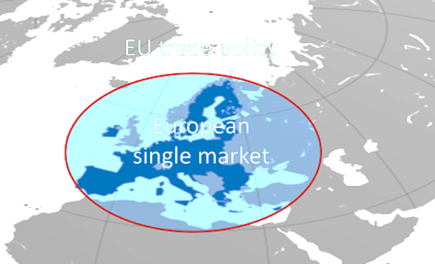  The EU believes in free and fair trade => applied it for the internal and the external dimension.  Treaty of Rome (signed in 1957): start to build the single mkt (more infra)  The treaty of Rome: trade policy is exclusive competence *of the Eu (individual MS can’t sign trade agreements).  *Some agreements cover areas of 'mixed' competence: EU approval + Nat Parl have to ratify (ex. EU-Singapore pf investments)  How EU can create a new trade Agreement  EC has power of initiative but needs the consent of the Council of the Eu (Council can approve + provide a mandate)  When at the end the EC proposes the text, the EP is given veto power (but no power to amend*). If EP says yes Council votes (QMV)  While the EC carries on the negotiations, EP and Council cooperate with the issuance of mandates through ordinary legislative procedure  *As in the Us: Trade Promotion Authority (TPA) = "fast track": congress can grant the President the power to negotiate, draft and sign trade agreements. Then Congress's has veto on the final bill with no amendments allowed.  WTO (1995 previously GATT): International organization concerned with the regulation of trade between nations.  Raising standards of living, income, expand trade in goods and services, sutainable development trhough optimal use ofr resources  PRINCIPLES  Tariff bindings: Members negotiate a bound MNF tariff. Basically this rate is the upper bound of the possible tariffs they be applied on a non-preferential basis (outside FTAs). They can apply lower levels if they like but on a non discriminatory basis.  Non-discrimination (MFN): All WTO members should receive the same treatment of the partner that receives the best treatment. MFN tariffs are the highest that WTO members charge, by default, one another, unless they are part of an FTA.  Single undertaking: Every item of the negotiation can’t be agreed separately = whole package incentivize to mediate  Consensus: In the WTO nothing is decided unless there is 'consensus'.  Reciprocity: WTO members should obtain mutually beneficial symmetric? reductions of trade barriers.  Negotiation forum: Agreements can be multilateral (all WTO members) and plurilateral (some WTO members). Negotiations not limited to tariffs reduction but also to trade-related issues (eg, services, standards, labour, competition, IPs).  The bulk of its activity comes from Uruguay rounds (1994) and before (Doha 2001 round is still ongoing with poor results)  Dispute settlement process:  I. the establishment of a panel to hear the dispute and to issue a report to be adopted by the Dispute Settlement Body (DSB)  II. The appeal of the panel report in front of the Appellate Body  However, since Obama the US blocked the appointments of judges of the Appellate Body, thus paralyzing it. Now when a country loses at the DSB-level it can avoid compliance by appealing to a non-functioning Appellate Body (ex. Us Steel). However, 23 WTO members (now 53, among which EU, China, Singapore …) created the new "Multi-party interim appeal arbitration arrangement" = appellate body for those who have signed the ad interim agreement  This trade dispute resolution is key in guaranteeing fair trade, hence to avoid:  Dumping: when a firm exports a product to another WTO member at a P that is lower than the normal value of the product (the domestic prices of the same product or the cost of production + reasonable π) and the domestic industry of the importing country is (or risks to be) seriously injured. Ex. Eu-Chi footware: dumping found by EC + huge damage to Eu industry (30% contraction) => tariffs. But hten Chi won appeal  Subsidies: when a Gov or any public body of a WTO member confers a financial benefit to a firm or a group of firms. Even if they could promote legitimate objectives (ex. social policy) they can have adverse effects giving favorable treatment to specific firms.  Ex. Subsidies: Airbus received subsidies from Eu, Boeing from Us => Wto confirmed both breaches => allowd Eu to increase tariffs, and viceversa! => at the end Eu-Us agreed to suspend retalitiory tariffs (2021)  Threat to national security: nothing in the agreement shall prevent a government from “Taking any action which it considers necessary for the protection of its essential security interests.” These interests are not defined… This is the pandora box, high potential for abuse. Obviously Wto can rule on whether the matter is of national interest. Ex. national security: US is imposing tariffs on foreign steel (25%). Chi, Candata, Mex retaliatory measures => WTO ruled no national security => Us appel to Appeate body ().  => if this is true you can impose tariff, but the exporting nation can file a complaint at WTO and open an investigation  The pyramid of preferences ranks the relationships of the EU wrt a decreasing degree of preference.  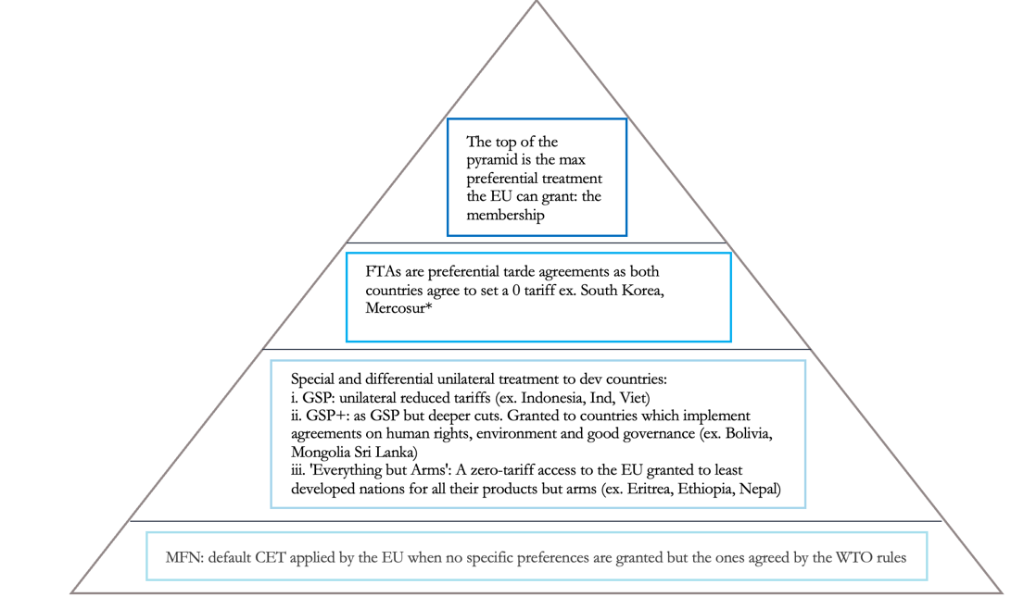  *In detail:  - Korea: Import duties are to be eliminated on nearly all products:  + Far reaching liberalisation of trade in services including in telecommunications, shipping, financial and legal services.  + Specific rules on a common jurisdiction for the protection of FDI  - Mercosur: strategic for the EU's de-risking and friendshoring: they hold vast reserves of the critical raw materials  => Farmers protests, activists critiques, human rights concerns have halted the agreement (negotiaitons from 1999).  Bilateral agreements violate the WTO’s MFN principle!  The problem is that WTO is not working => allowed states to go ahead. WTO allows those preferential bilateral agreements as an exception to the MN principle if two conditions are fulfilled:  1st: Tariffs and other trade barriers should be reduced or removed on substantially all sectors.  2nd: Countries that are not part of the agreement should not find trade with the newly created group any more restrictive than before (for CU weighetd avg of previous tariff barriers)  Why a network of bilateral/regional trade agreements is not a perfect subs  tute for a WTO mul  lateral agreement?  Trade diversion, ie, effcient exporters lose market shares abroad because their respect to countries are not part of FTAs.  FTAs increases the complexity / costs of trade since each agreement has its own adm rules and requirements (huge annexes with rules of origin)  Bilateral has bargaining pow issues

